**Milestone 2**

**Github link:**

**E. Conceptual & logical model: identify all entity sets, write each relationship between entity sets as two sentences, add attributes to entity sets, write the functional dependencies, replace multi-attribute keys with surrogate keys, perform the normalization analysis and correct normalization problems, draw the ERD that shows the entity sets and their relationships**

The Entities of the Conceptual and Logical model are:

* Coach_details
* Team
* Players
* Match
* Umpire
* Stadium
* Sponsor
* Ticket_details

**The relationships between entity sets:**

There are mainly one-to-many and many-to-one relationships in the ERD diagram.

coach_details to Team: Each coach belongs to one team but a team can have multiple coaches.

Team to Players: A team can have multiple players. Each player belongs to a single team.

coach_details to Match: Each match is connected with a coach but each coach can be connected or associated with different matches.

Match to umpire: Each match has multiple umpires but each umpire can supervise several matches.

Match to Stadium: Each stadium hosts multiple matches but each match is hosted in a stadium.

Stadium to Sponsors: Each stadium is sponsored by multiple sponsors. A sponsor can sponsor multiple stadiums.

Sponsors to Ticket_details: Each sponsor is associated with a specific type of ticket. Multiple sponsors can be associated with different types of tickets.

**Attributes:**

The attributes present in the diagram are,

* Coach_details (coach_id, Nationality, Name, Team_id)
* Team (Team_id, Team_name, Total_players, Team_ranking)
* Player (player_id, player_name, nationality, Player_type, Team_id)
* Match (match_id, Team1, Team2, Winner, Run_score, coach_id)
* Umpire (umpire_id, umpire_name, nationality, umpire_rank, match_id)
* Stadium (Stadium_id, Stadium_name, location, Sponsor_id, match_id)
* Sponsors (Sponsors_id, Sponsor_name, Total_distributed_amount, Ticket_id)
* Ticket_ details (Ticket_id, Ticket_type, Qty, Price)

**Functional Dependencies:**

* Coach_details (coach_id → nationality, name)
* Team (team_id → team_name, total_players, team_ranking)
* Player (player_id → player_name, nationality, player_type)
* Player (team_id → player_id)
* Match (match_id → Team1, Team2, Winner, Run_score, coach_id)
* Umpire (umpire_id → umpire_name, nationality, umpire_rank)
* Umpire (match_id → umpire_id)
* Stadium (Stadium_id → Stadium_name, location)
* Sponsor (sponsor_id → Sponsor_name, Total_distributed_amount)
* Sponsor (match_id → Sponsor_id)
* Ticket (Ticket_id → Ticket_type, Qty, Price)
* Ticket (match_id → ticket_id)

**Normalization analysis:**

1. All the tables contain atomic values. Therefore they are in 1NF.
2. There are no partial dependencies in any table. Therefore they are in 2NF.
3. Though there are some transitive dependencies present in some tables. So, they are in 3NF.
4. In the ‘Match’ table, ‘coach_id’ relies on ‘match_id’, which is not a primary key. It is a non-prime attribute. To achieve 3NF, we need to erase the dependency of ‘coach_id’ on ‘match_id’.
5. Again in the ‘Stadium’ table, ‘Sponsors_id’ relies on ‘Stadium_id’. ‘Stadium_id’ is not a primary key. Rather it is a non-prime attribute. For achieving 3NF, it requires removing the dependency of ‘Sponsors_id’ on ‘Stadium_id’.

**Correction of Normalization Problems:**

For achieving 3NF and the correction of normalization problems, it requires to do the following:

1. Creating a new table for ‘Match_coach_deatils’ with ‘match_id’ as the primary key and ‘coach_id’ as a foreign key.
2. Creating a new table for ‘Stadium_Sponsors’ with ‘Stadium_id’ as the primary key and ‘Sponsors_id’ as a foreign key.

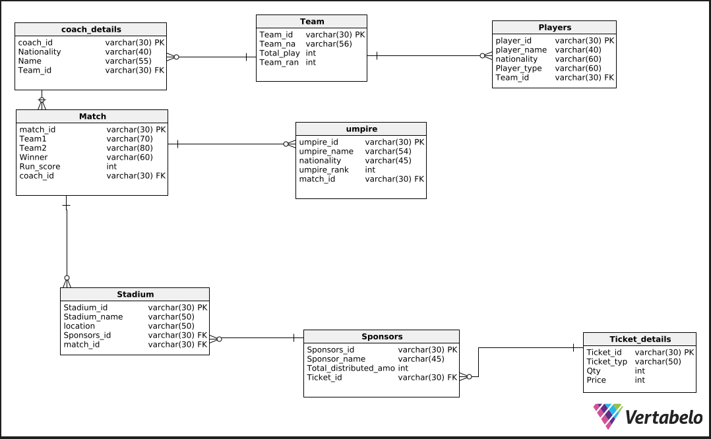

**F. Physical model: replace all M:N relationships with bridge entity sets, clearly define all attributes' data types (including sizes), draw the ERD for the physical model that is free of errors (Vertabelo shows you the errors), generate the SQL needed to build the database, and then build the database, showing screen shots that prove that the database exists on your system. Use the command "show tables;" to show a list of the tables in the database, and then use "describe" along with each table name to show the columns in each table you created.**

**SQL generation to build the database:**

* First, we need to draw the diagram
* Then it needs to click the Generate SQL Script icon in the top bar
* Then the next step is clicking the Generate option
* Then click the SQL file button in the main toolbar
* After that, we need to choose whether we want to generate a Create or Drop script
* Next, we identify which elements should be included in it
* We click Generate
* Then clicking the Download button to save this file.

**Building the database:**

* First I opened XAMPP
* It launched the Apache Server and MySQL Database
* I create a database via phpMyAdmin
* I chose the SQL file which I exported from Vertabelo
* I then import it in xammp.

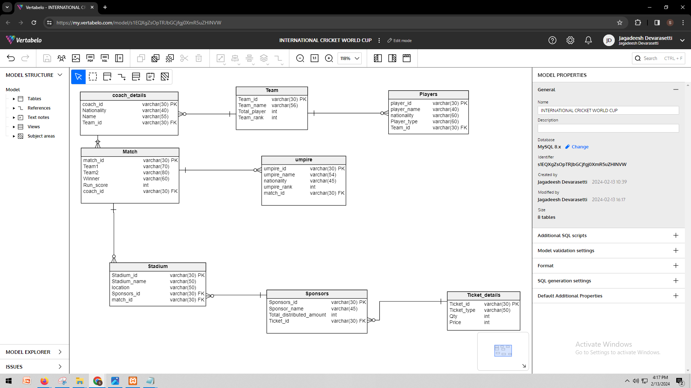

**G. Populate the database with data: similar to how I explained to you how I took a data set of music data and used it to populate my database, here I need you to clearly explain how you are transforming your data into commands for inserting data into your database. After the explanation, include screenshots (or a link to your github) that shows all the insert statements organized in SQL files. Then show screenshots of the data stored in your database after you run the insert statements. Use "select * from " along with each table name to show the data in each table.**

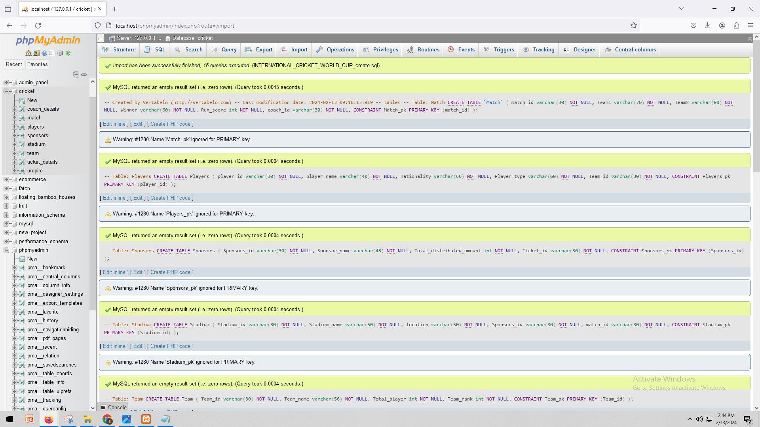

INSERT INTO `team`(`Team_id`, `Team_name`, `Total_player`, `Team_rank`) VALUES ('t1','Australia','14','1');

INSERT INTO `team`(`Team_id`, `Team_name`, `Total_player`, `Team_rank`) VALUES ('t2','New Zealand','13','4');

INSERT INTO `team`(`Team_id`, `Team_name`, `Total_player`, `Team_rank`) VALUES ('t3','South Africa','11','3');

INSERT INTO `team`(`Team_id`, `Team_name`, `Total_player`, `Team_rank`) VALUES ('t4','india','14','2')

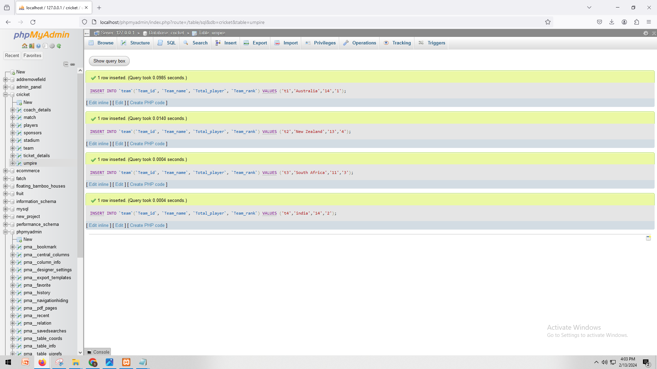

INSERT INTO `coach_details`(`coach_id`, `Nationality`, `Name`, `Team_id`) VALUES ('c1','Australia','Brad Hodge','t1');

INSERT INTO `coach_details`(`coach_id`, `Nationality`, `Name`, `Team_id`) VALUES ('c2','New Zealand','Stephen Fleming','t2');

INSERT INTO `coach_details`(`coach_id`, `Nationality`, `Name`, `Team_id`) VALUES ('c3','South Africa','Gary Kirstern','t3');

INSERT INTO `coach_details`(`coach_id`, `Nationality`, `Name`, `Team_id`) VALUES ('c4','india','Rajeev Kumar','t4')

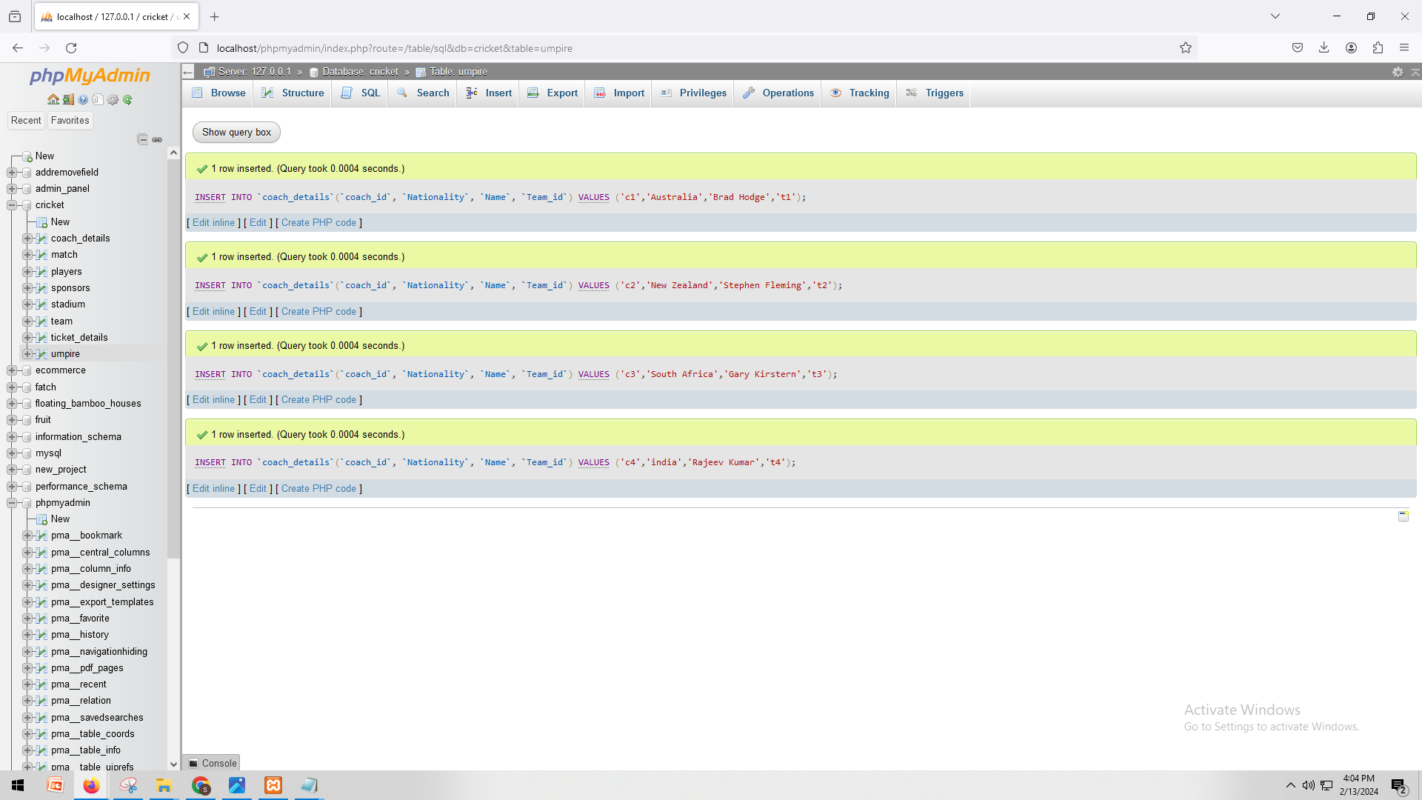

INSERT INTO `match`(`match_id`, `Team1`, `Team2`, `Winner`, `Run_score`, `coach_id`) VALUES ('m1','Australia','India','Australia','300','c1');

INSERT INTO `match`(`match_id`, `Team1`, `Team2`, `Winner`, `Run_score`, `coach_id`) VALUES ('m2','New Zealand','Australia','New Zealand','300','c2');

INSERT INTO `match`(`match_id`, `Team1`, `Team2`, `Winner`, `Run_score`, `coach_id`) VALUES ('m3','South Africa','India','India','300','c3');

INSERT INTO `match`(`match_id`, `Team1`, `Team2`, `Winner`, `Run_score`, `coach_id`) VALUES ('m4','Australia','India','Australia','300','c4')

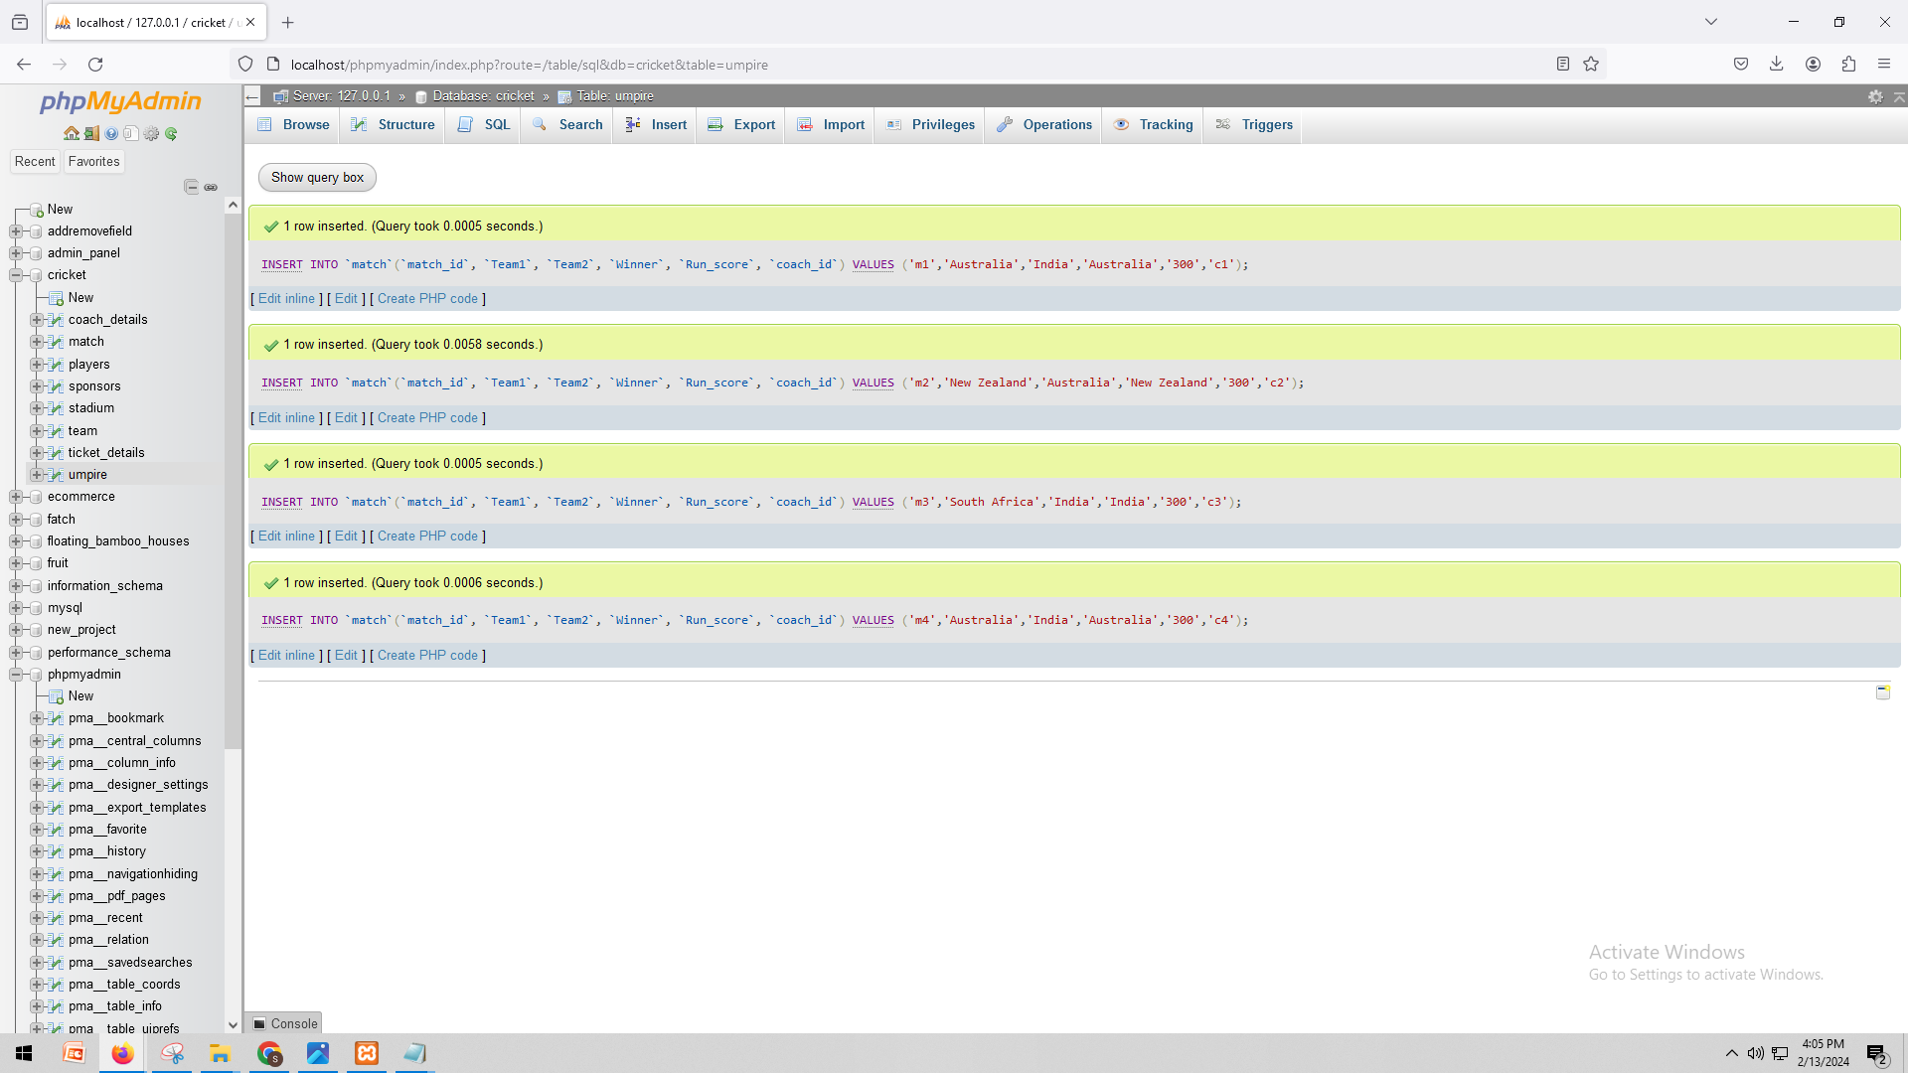

INSERT INTO `ticket_details`(`Ticket_id`, `Ticket_type`, `Qty`, `Price`) VALUES ('tid1','1st floor','2','4500');

INSERT INTO `ticket_details`(`Ticket_id`, `Ticket_type`, `Qty`, `Price`) VALUES ('tid2','3rd floor','2','545454');

INSERT INTO `ticket_details`(`Ticket_id`, `Ticket_type`, `Qty`, `Price`) VALUES ('tid3','1st floor','2','6789');

INSERT INTO `ticket_details`(`Ticket_id`, `Ticket_type`, `Qty`, `Price`) VALUES ('tid4','VIP','2','76760')

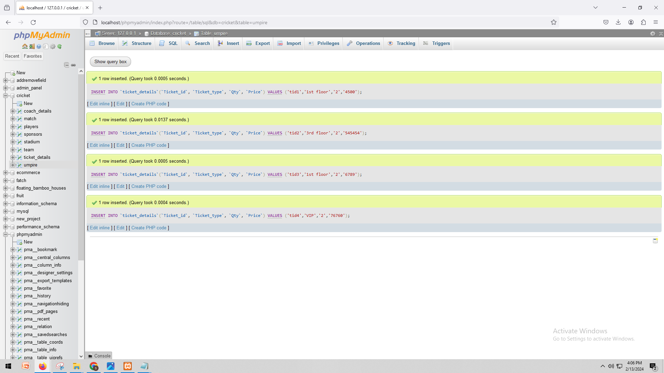

INSERT INTO `sponsors`(`Sponsors_id`, `Sponsor_name`, `Total_distributed_amount`, `Ticket_id`) VALUES ('s1','Emirates','19090','tid1');

INSERT INTO `sponsors`(`Sponsors_id`, `Sponsor_name`, `Total_distributed_amount`, `Ticket_id`) VALUES ('s2','Dream11','23424','tid2');

INSERT INTO `sponsors`(`Sponsors_id`, `Sponsor_name`, `Total_distributed_amount`, `Ticket_id`) VALUES ('s3','Nissan','4565546','tid3');

INSERT INTO `sponsors`(`Sponsors_id`, `Sponsor_name`, `Total_distributed_amount`, `Ticket_id`) VALUES ('s4','Nium','675777','tid4');

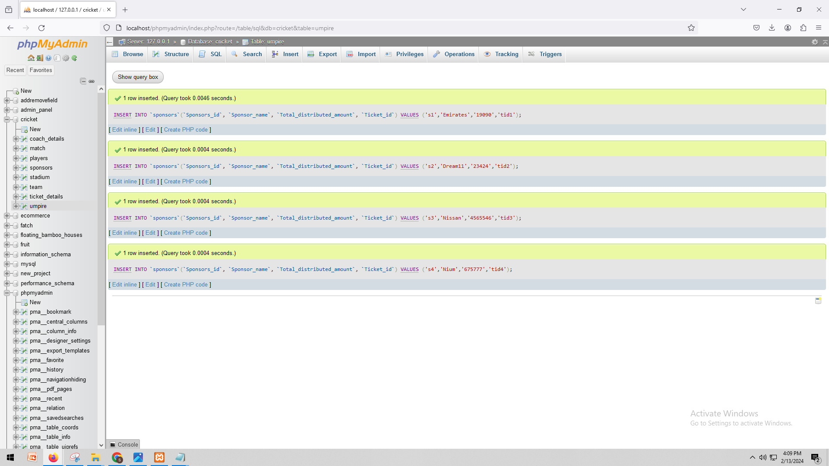

INSERT INTO `players`(`player_id`, `player_name`, `nationality`, `Player_type`, `Team_id`) VALUES ('p1','Harbhajan','indian','bowler','t1');

INSERT INTO `players`(`player_id`, `player_name`, `nationality`, `Player_type`, `Team_id`) VALUES ('p2','Pollard','West Indies','All Rounder','t2');

INSERT INTO `players`(`player_id`, `player_name`, `nationality`, `Player_type`, `Team_id`) VALUES ('p3','Plessis','South Africa','batsman','t3');

INSERT INTO `players`(`player_id`, `player_name`, `nationality`, `Player_type`, `Team_id`) VALUES ('p4','Buttler','England','Wk','t4');

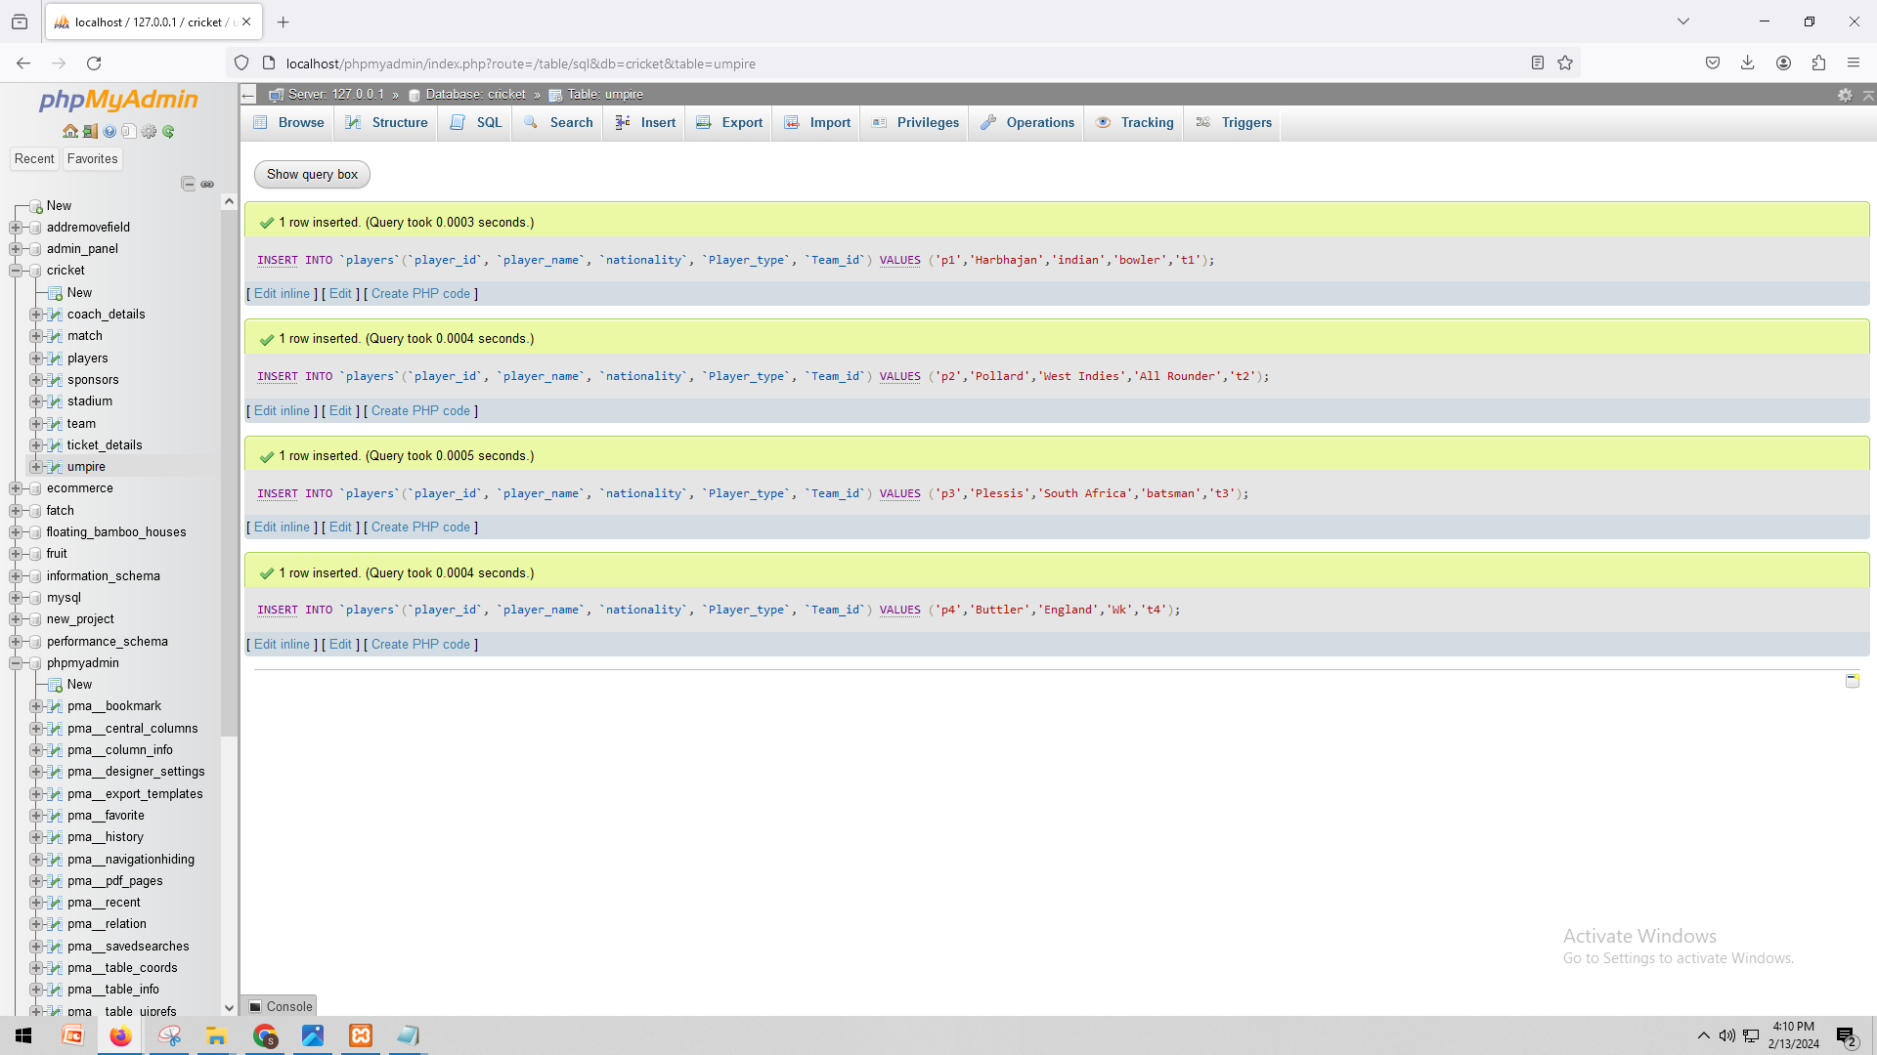

INSERT INTO `stadium`(`Stadium_id`, `Stadium_name`, `location`, `Sponsors_id`, `match_id`) VALUES ('sta1','MCA Stadium','Pune','s1','m1');

INSERT INTO `stadium`(`Stadium_id`, `Stadium_name`, `location`, `Sponsors_id`, `match_id`) VALUES ('sta2','M. C.Stadium','England','s2','m2');

INSERT INTO `stadium`(`Stadium_id`, `Stadium_name`, `location`, `Sponsors_id`, `match_id`) VALUES ('sta3','PCA Stadium','Australia','s3','m3');

INSERT INTO `stadium`(`Stadium_id`, `Stadium_name`, `location`, `Sponsors_id`, `match_id`) VALUES ('sta4','W Stadium','South Africa','s4','m4');

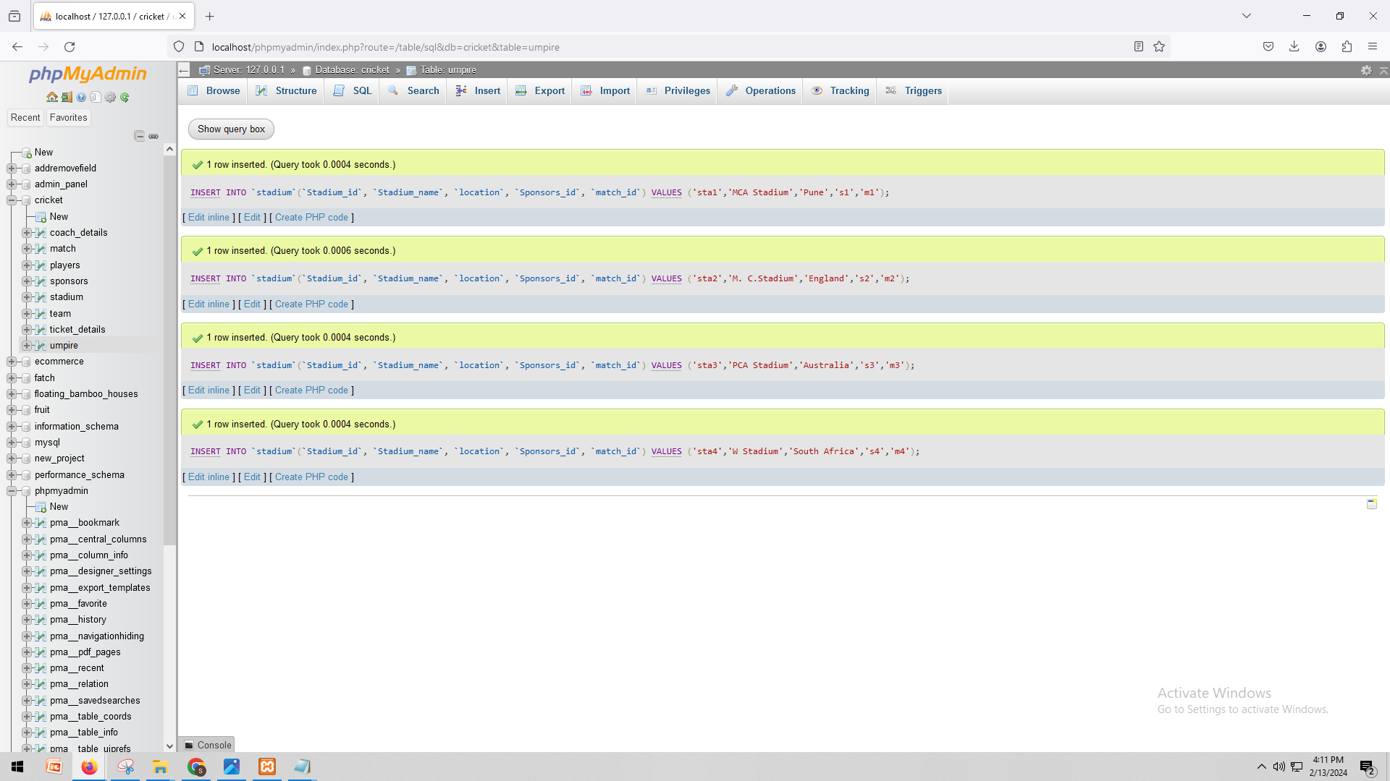

INSERT INTO `umpire`(`umpire_id`, `umpire_name`, `nationality`, `umpire_rank`, `match_id`) VALUES ('u1','Asnani','India','3','m1');

INSERT INTO `umpire`(`umpire_id`, `umpire_name`, `nationality`, `umpire_rank`, `match_id`) VALUES ('u2','RKIllingworth','England','2','m2');

INSERT INTO `umpire`(`umpire_id`, `umpire_name`, `nationality`, `umpire_rank`, `match_id`) VALUES ('u3','NJ Llong','England','3','m3');

INSERT INTO `umpire`(`umpire_id`, `umpire_name`, `nationality`, `umpire_rank`, `match_id`) VALUES ('u4','SJ Davis','England','3','m4')

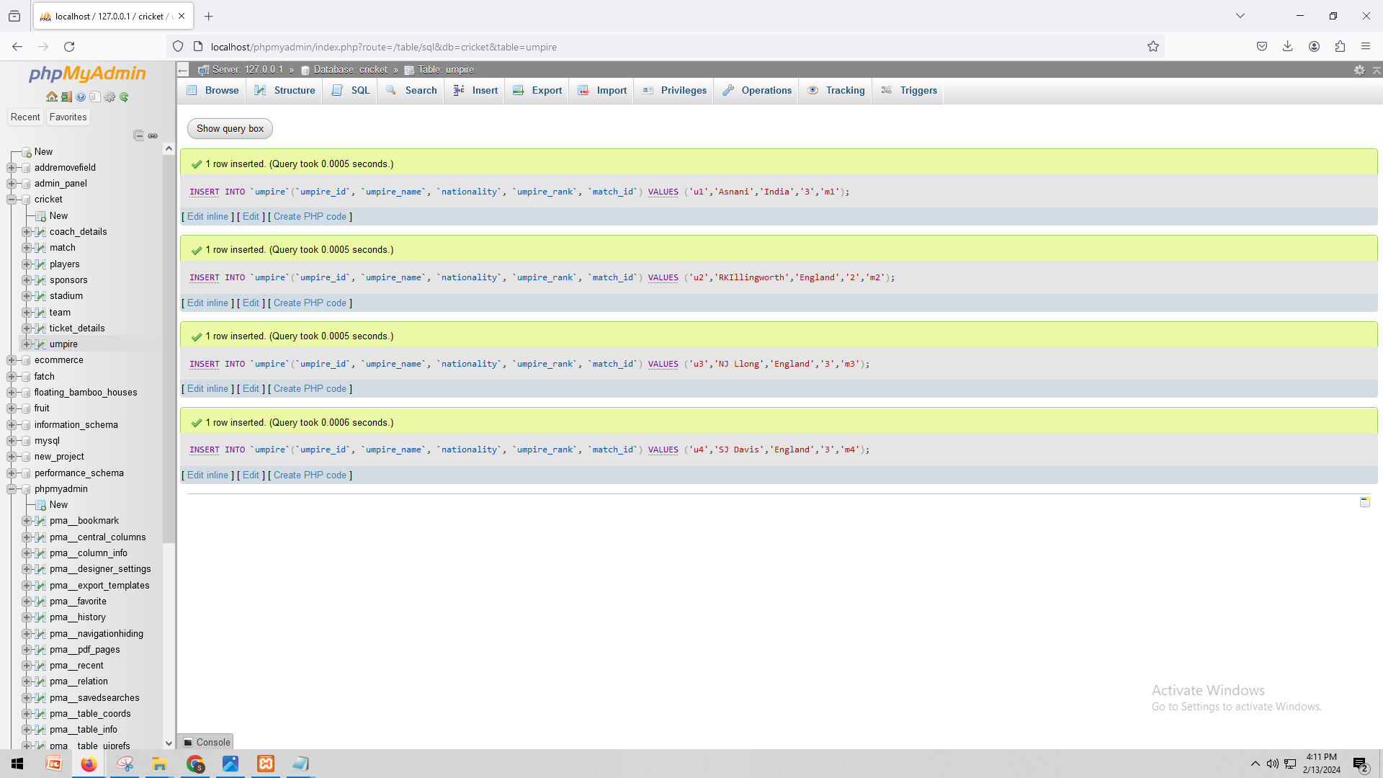

Show the data:

SELECT * FROM `coach_details`

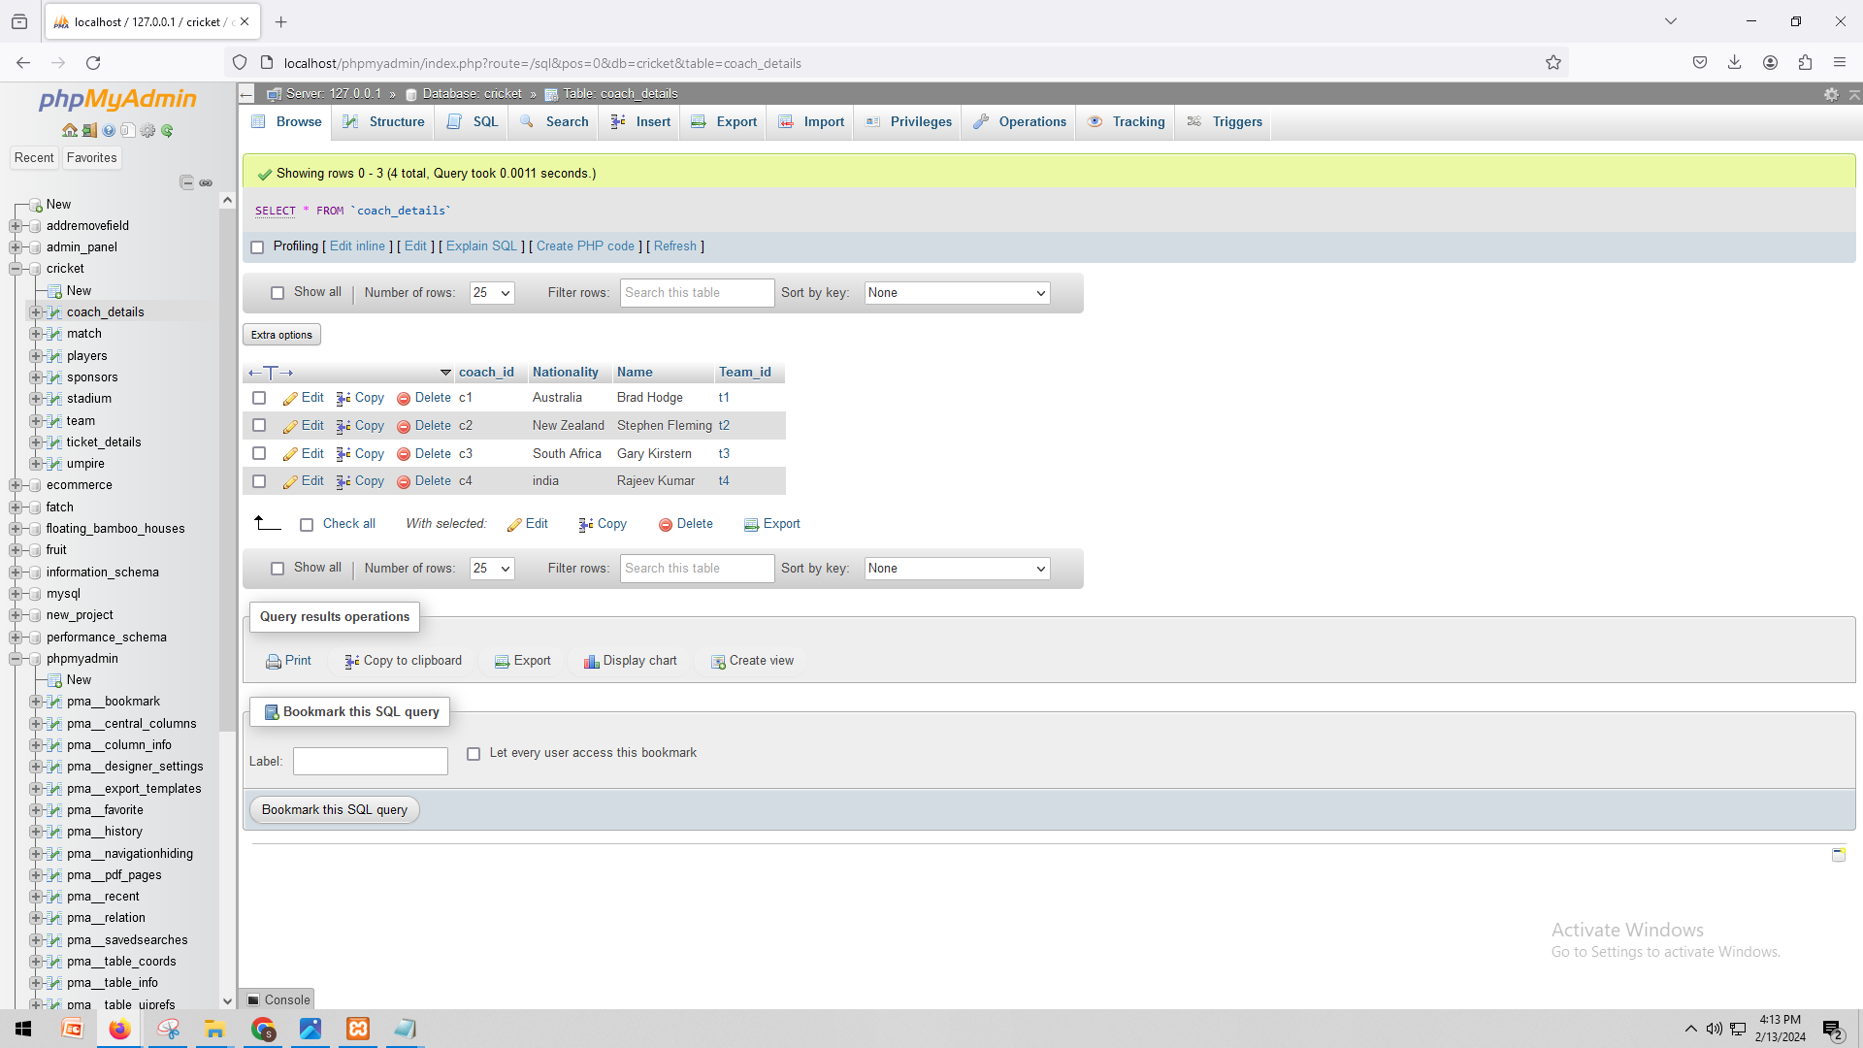

SELECT * FROM `match`

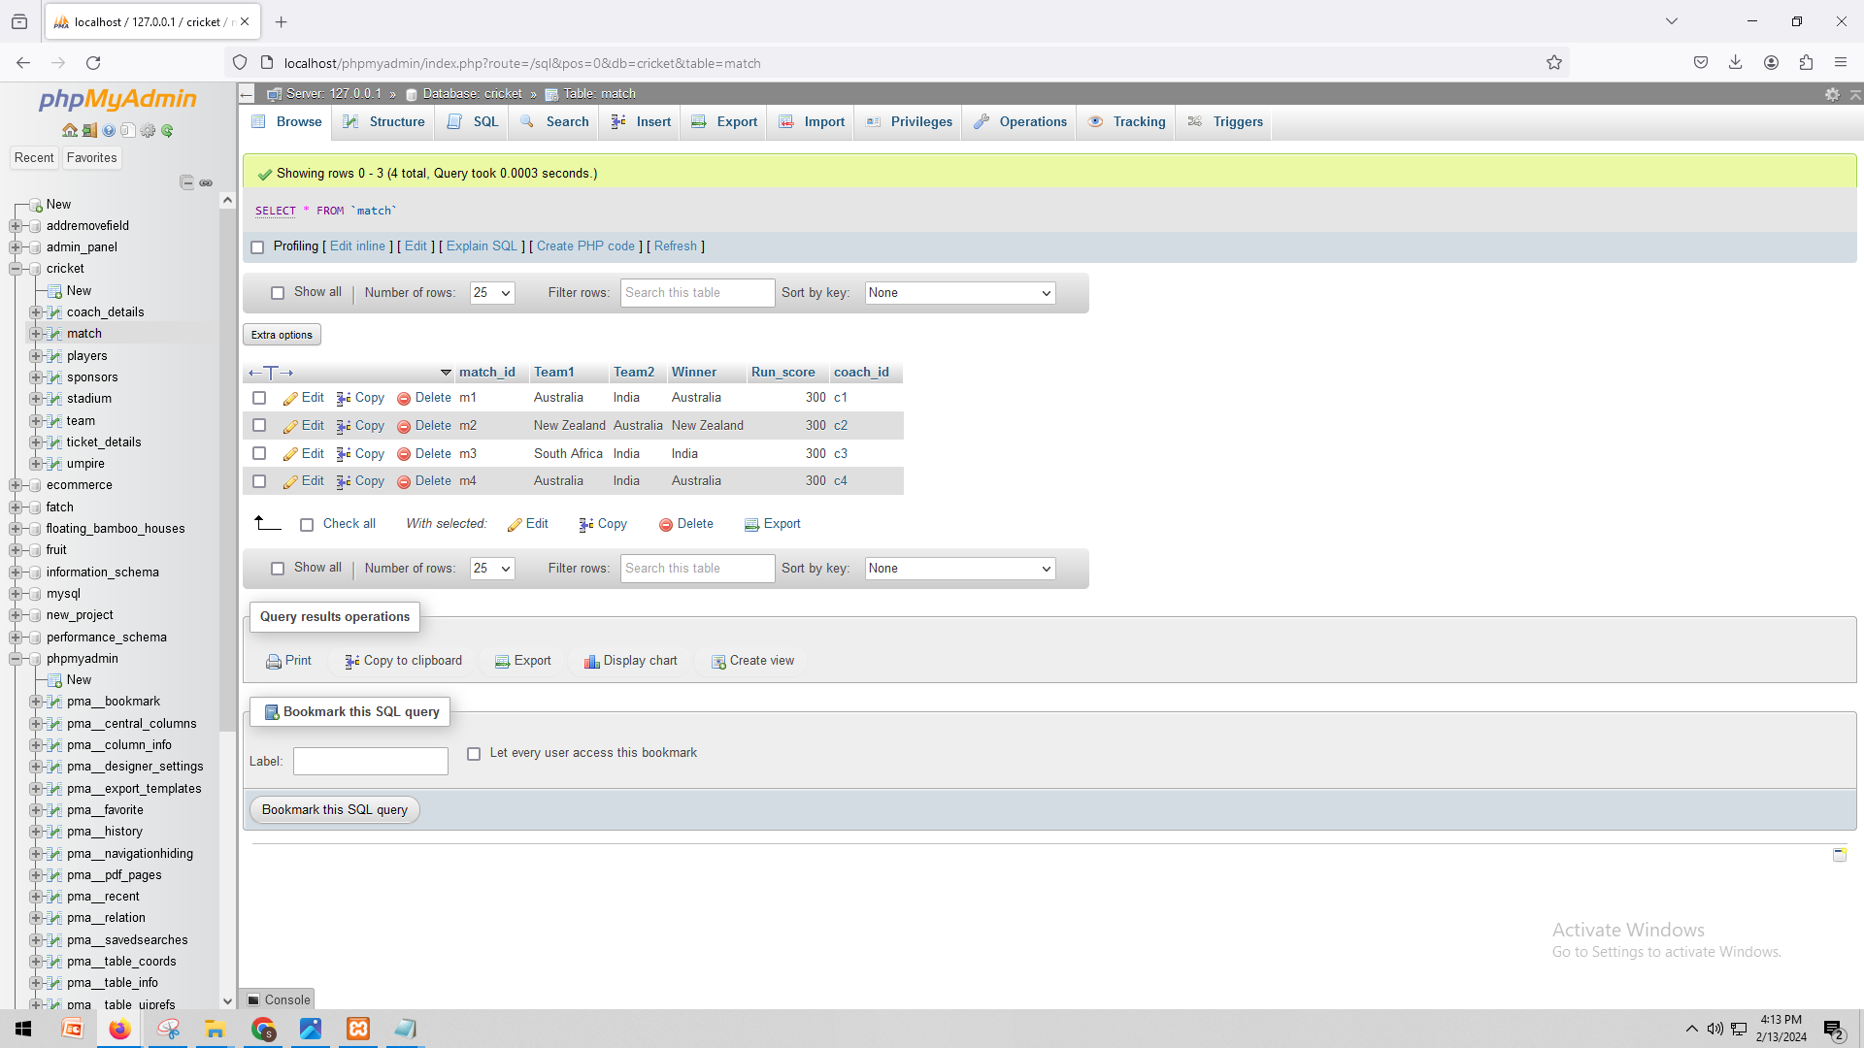

SELECT * FROM `players`

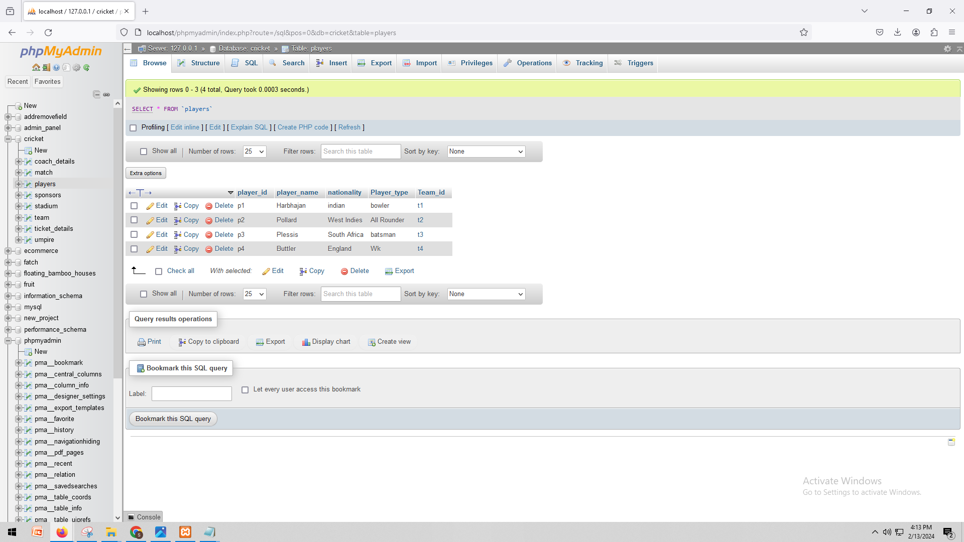

SELECT * FROM `sponsors`

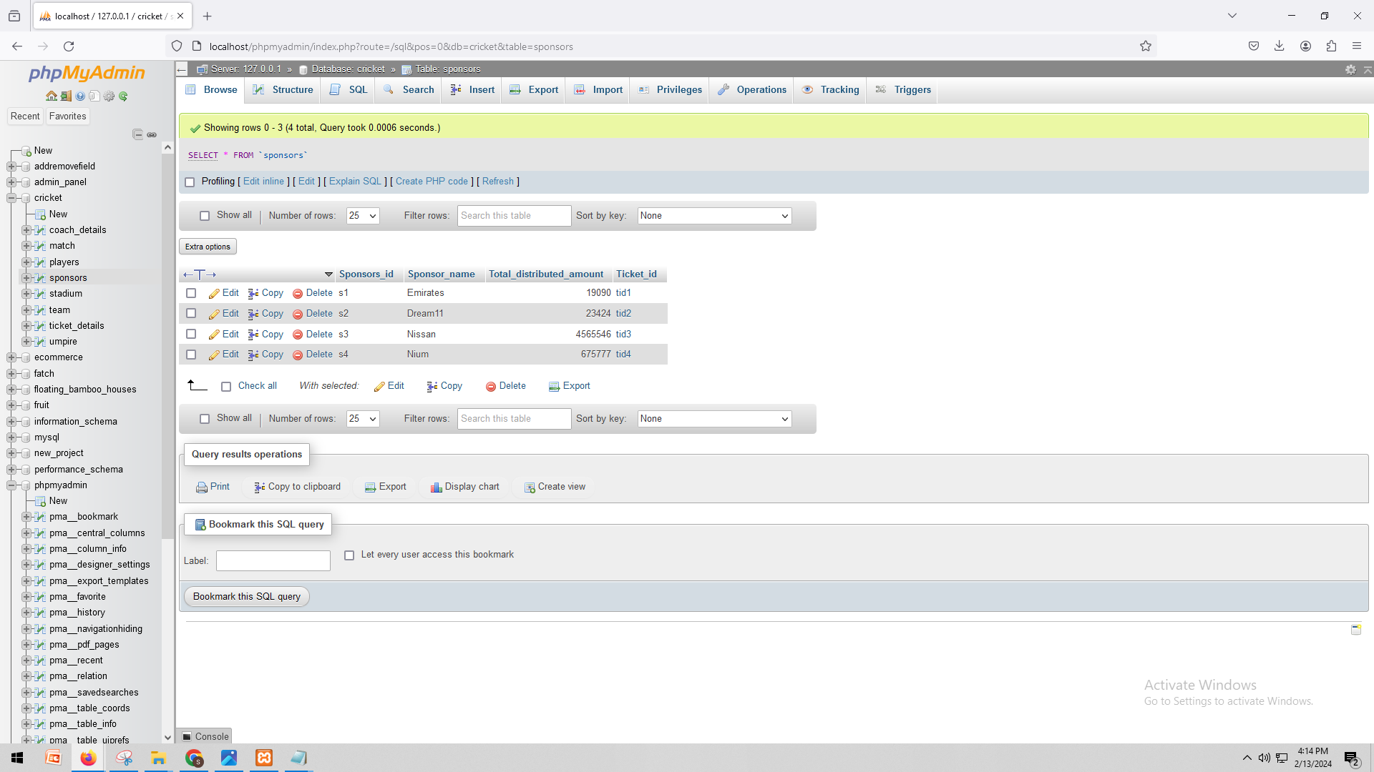

SELECT * FROM `stadium`

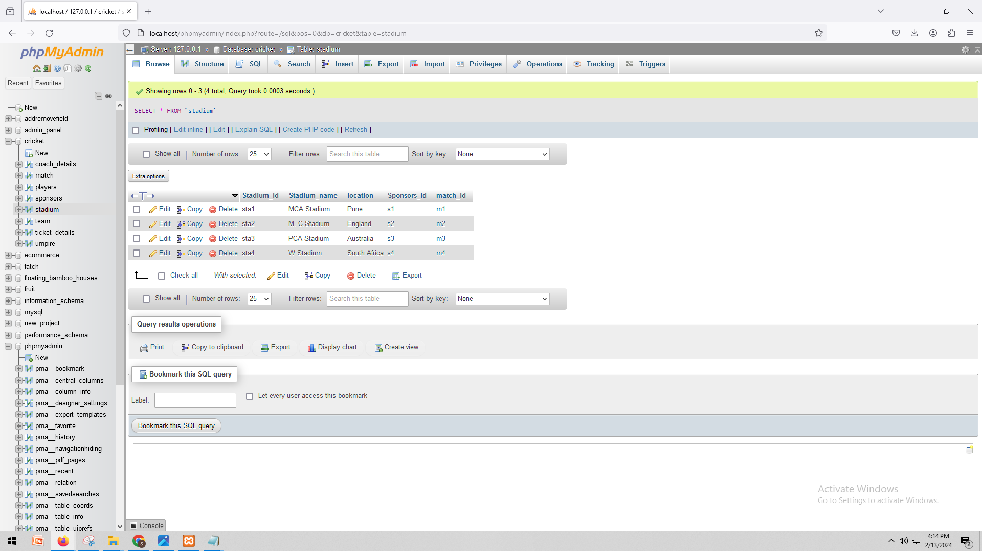

SELECT * FROM `team`

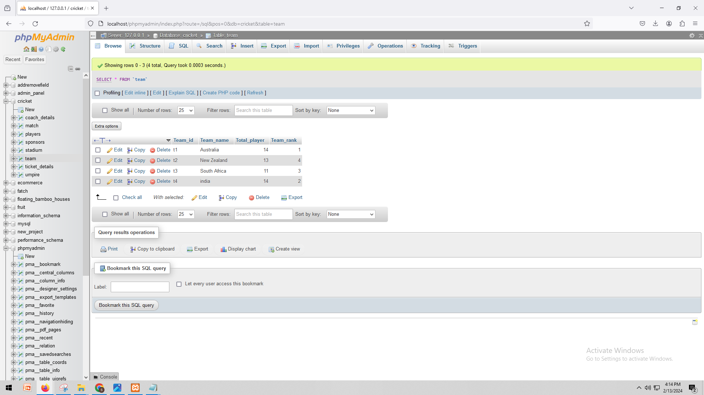

SELECT * FROM `ticket_details`

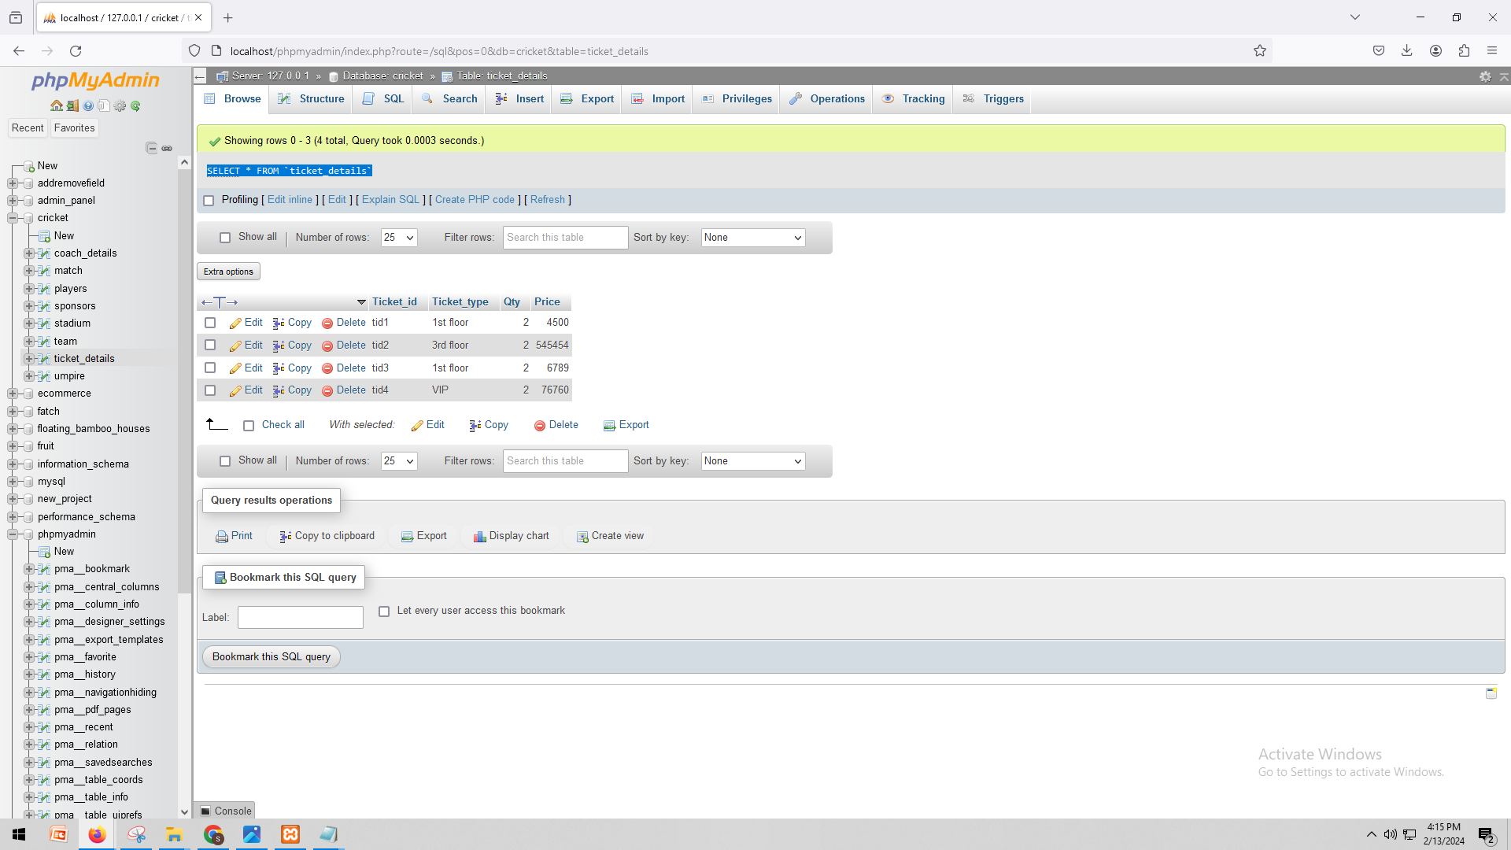

SELECT * FROM `umpire`

